**BIOL 803 (503) – FALL 2022**

**Plant Biotechnology**

Fall Term (2025)

CALENDAR DESCRIPTION

This discussion-based seminar course will explore the recent literature on the use of plants in commercial applications of interest to the biotechnology industry. Examples of topics covered might include expressing recombinant proteins such as human insulin in plants, enhancing stress and disease tolerance in crops, biofortification of crops, and engineered phytoremediation. Students will examine the various methods of genetic engineering of plants, current challenges and future potential of plant biotechnology, and ethical considerations and limitations of these technologies.

**Instructor**

Dr W.A. Snedden; [sneddenw@queensu.ca](mailto:sneddenw@queensu.ca)

Office Hrs: TBA

**Learning Objectives**: The main objective of the course is to help students develop the skills needed to critically read the primary scientific literature on plant biotechnology. You will learn about different techniques used to genetically engineer plants and have the opportunity to design a research plan in the form of a grant proposal.

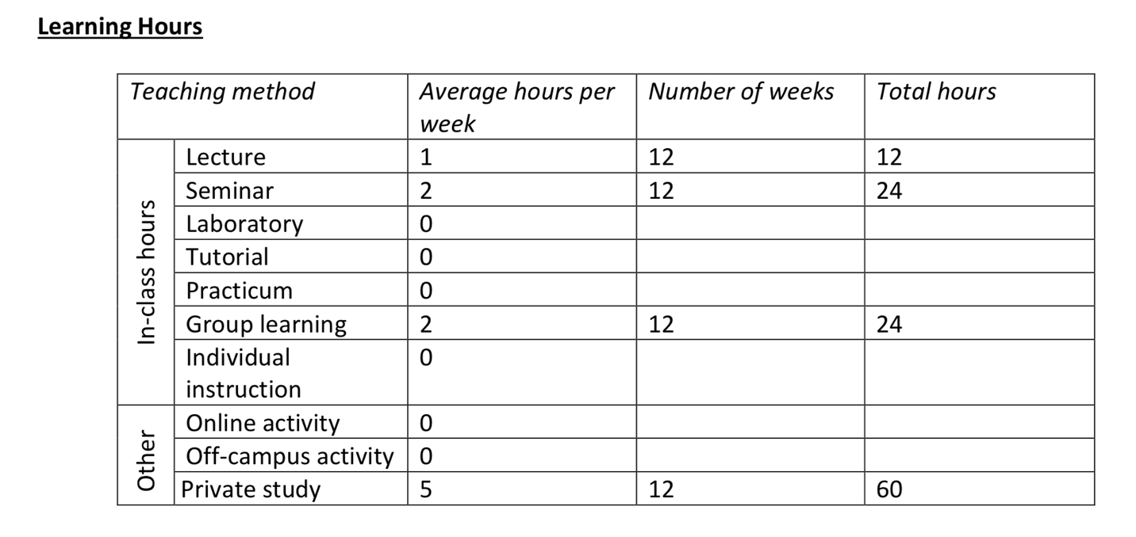Total hours on task 120

Course evaluation will be comprised of:

* 2 seminars (one on a research paper, one outlining your own project plan): 30%
* Peer evaluations of classmates’ seminars: 10%
* Research project proposal: 20%
* Participation in class: 10%

**Students taking Biol503 as a graduate course (Biol803**) will also be required to give a lecture (15%) to the class on a topic assigned by the instructor and write an additional essay as a popular press article (15%).

All components of this course will receive numerical percentage marks. The final grade you receive for the course will be derived by converting your numerical course average to a letter grade according to Queen’s Official Grade Conversion Scale:

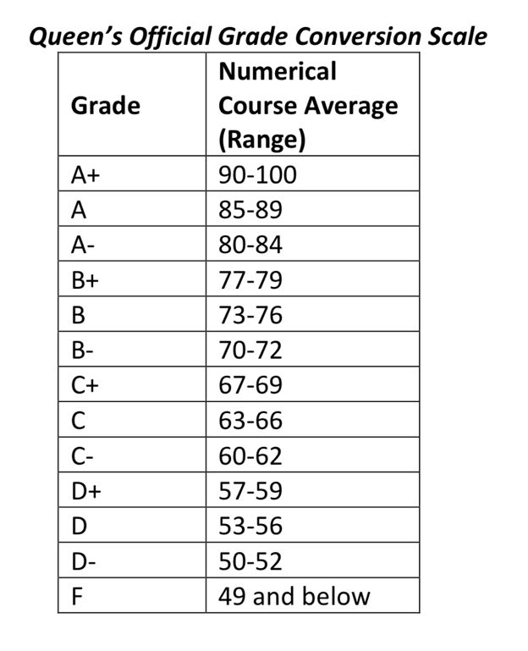

**Academic Integrity and Queen’s Code of Conduct**

Students are responsible for familiarizing themselves with the regulations concerning academic integrity and for ensuring that their assignments and conduct conform to the principles of academic integrity. Information is available in the Arts and Science Calendar (see Academic Regulation 1 - http://www.queensu.ca/artsci/academic-calendars/regulations/academic-regulations, on the Arts and Science website (see http://www.queensu.ca/artsci/academics/undergraduate/academic- integrity), and at Biology’s website (http://www.queensu.ca/biology/undergrad/integrity.html) and from the instructor of this course. Departures from academic integrity include plagiarism, use of unauthorized materials, facilitation, forgery and falsification, and are antithetical to the development of an academic community at Queen's. Given the seriousness of these matters, actions which contravene the regulations on academic integrity carry sanctions that can range from a warning or the loss of grades on an assignment to the failure of a course to a requirement to withdraw from the university.

**Accommodation Policy, Exam Conflicts, and Other Conflicts**

Students who feel they need accommodations for disabilities or extenuating circumstances or have a conflict between exams or other commitments should consult the Biology Department’s website for details about how to proceed (http://www.queensu.ca/biology/undergrad/integrity.html). In general, the earlier a course coordinator is apprised of an extenuating circumstance, the more likely an accommodation can be made. Students are encouraged to be proactive in anticipating difficulties, when it is possible to do so.

Students may apply to write a make-up or deferred exam if they have an exam conflict as defined in the Academic Regulations of the Faculty (See Arts and Science Calendar Regulation 8 - http://www.queensu.ca/artsci/academic-calendars/regulations/academic-regulations). In this case, the student should report to the Exams Office first to verify that there is a genuine exam conflict. Biology professors will not consider your situation to be a conflict unless it meets the criteria set out by the Faculty of Arts and Sciences.

Students may request a make-up or deferred exam if they have an exam conflict with off-campus travel associated with a field course (e.g BIOL-307/3.0 or 407/3.0) that is held during the fall or winter terms.

Accommodation of Disabilities

Queen's University is committed to achieving full accessibility for persons with disabilities. Part of this commitment includes arranging academic accommodations for students with disabilities to ensure they have an equitable opportunity to participate in all of their academic activities. If you are a student with a disability and think you may need accommodations, you are strongly encouraged to contact the Disability Services Office (DSO) and register as early as possible. For more information, including important deadlines, please visit the DSO website at: http://www.queensu.ca/hcds/ds/

3